Form B

Hotel Booking Form

This form must be returned by
22 Nov 2019
Online

Orient Event Service
Tel: (+8621) 51099795
E-mail: booking@orient-explorer.com.cn

Attn: Ms.Lancy
Please fill up the form:  booking@orient-explorer.com.cn  Attn: Ms. Lancy  Make online booking at:  https://www.orient-explorer.net/woca | (Please use block letters or attach business card.)  Contact Person: ____________________________________________  Organization: _________________________________________________  Address:______________ ___________________________________  Country_____________________ Postal Code: ____________________  Tel:_________________ ________ Fax:_________________________  Email:_____________ ______________________________________
Hotel booking Details:
Guest Name: ______________ ___________________________________________________
Hotel Preferred: 1st choice _______________________ 2nd choice _________________________
Single/twin share room /double room with 1 king-size bed (circle accordingly) No of room(S): _______
Check in date and time (China local time zone) ___________ check out date___________

Airport Limousine service: (RMB430 per way for 1-2 persons; RMB480 per way for 3-4 persons.)

I need for Arrival Departure, Number of person(s): __________
Arrival flight no._________ arrival local date__________ estimated arrival time _____
Departure flight no. ______ Departure date___________ Departure time __________

Local Tours: (seat-in-coach, select accordingly)
Best of Shanghai Full day Tour – RMB560 net per person
Suzhou and Zhouzhuang Water Village Day Tour – RMB980 net per person including group lunch
Hangzhou, Heaven on Earth Day Tour – RMB1180 net per person including group lunch
Number of person(s): ____ Preferred Date ___________

Interpreter service: preferred language_________ withdate from ______ to _______

Payment type:
I hereby authorize Orient Event Service to charge my credit card for the booking;
Payment via credit card and bank transfer is subjected to a 3% administration fee.
by bank transfer, Please indicate guest name/event name/hotel booked on transfer slip.

CREDIT CARD details
Visa Card AMEX JCB Master Card
Name of Credit Cardholder: _________________________ Expiry Date (mm/yy): ____________
Credit Card Number: ____________________CCV Code:_______Cardholder’s Signature: ____________
Special notes from you if any: ________________________________________________________

Official Recommended Hotels

Name of Hotel | Travel Distance to Exhibition | Cost Per Room Per Night （Including Breakfast） |  | Other benefits
 |  | Single  Room | Twin/double  Room
Jinjiang Inn Expo  Standard Room | 20 minutes  by taxi | RMB320 net | RMB320 net | Free internet
Ibis Lianyang Shanghai  Standard Room | 5 mins by taxi | RMB430 net | RMB430 net | Free Internet
Manju Century Hotel  Deluxe Room | 5 minutes  By free shuttle bus | RMB500 net | RMB500 net | Free Internet  Free shuttle bus
Parkview Hotel(4*)  Superior Room | 15 minutes  By free shuttle bus | RMB700 net | RMB750 net | Free Internet  Free Shuttle bus
Grand Mercure Century Park(5*)Superior room | 8 minutes by  free shuttle bus | RMB 950 net | RMB 950 net | Free Internet  Free shuttle bus in the morning
Jumeirah Himalayas Hotel(5*) Deluxe room | 3 minutes by walking | RMB 1400+16.6% | RMB 1550+16.6% | Free Internet
Kerry Hotel Pudong Shanghai Deluxe room | 2 minutes by walk | RMB 1600+16.6% | RMB 1800+16.6% | Free Internet
Notes:
- Payment for hotel room must be made on or before 22nd Nov. 2019 to Orient Event Service directly.
Terms & conditions：
- Shanghai Orient Event Service is the official travel agent for the event. Once the agent receives your booking, you will receive a confirmation letter.
- Cancellation of booking must be made two weeks before your arrival date otherwise a one-night room charge will be applied. Jumeirah Himalayas and Kerry Hotel will charge the whole room nights as the cancellation charges.
- In case of failure to show up, a one-night room fee will be charged as penalty. Any balance will be refunded one week after the fair. Jumeirah Himalayas and Kerry Hotel will charge the whole room nights as the cancellation charges.

Introduction of Official Hotels
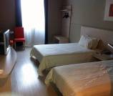 | Jinjiang Inn Shanghai Expo  Opened in 2008  Located in Shanghai Expo area, close to Metro Station. Can satisfy the business, travel, leisure and so on the different customers' needs.  Location Distance from hotel  Shanghai Pudong International Airport 34 km  Shanghai Hongqiao Airport (Terminal II) 22 km  Address: No. 300 Ban Quan Road, Pudong, Shanghai
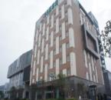 | Ibis Lianyang Shanghai  The worldwide budget ibis hotels are owned by Accor hotels and offer more than 983 hotels in 58 countries. Beds feature high-tech bases and mattresses, fluffy pillows and soft duvets. Rooms feature all the standard amenities, a desk and either a double or two single beds. This chain offers extended breakfast times which run from 4:00 a.m. to midday.  Location Distance from hotel  Shanghai Pudong International Airport 33 km  Shanghai Hongqiao Airport (Terminal I) 28 km  Address: 200 Fangdian Road (Fangdian Lu), Pudong
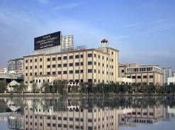 | Manju Century Hotel  Opened in 2011  Located close to Lianyang and Biyun international communities, with easy access to Shanghai New International Expo Center and Century Park.  Location Distance from hotel  Shanghai Pudong International Airport 30 km  Shanghai Hongqiao Airport (Terminal II) 28 km  Address: 1609 Luoshan Road, Pudong, Shanghai
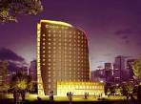 | Parkview Hotel  Opened in 2007 Total rooms: 209  The hotel makes a great place to kick back and relax after a long day of sightseeing.The hotel is just a seven-minute walk from the Science and Technology Museum Metro Station, a 10-minute drive from the Shanghai New International Expo Center and a 30-minute drive from Pudong International Airport.  Location Distance from hotel  Shanghai Pudong International Airport 33.15 km  Shanghai Hongqiao Airport (Terminal II) 24.98 km  Address: No. 555 Ding Xiang Road, Pudong, Shanghai
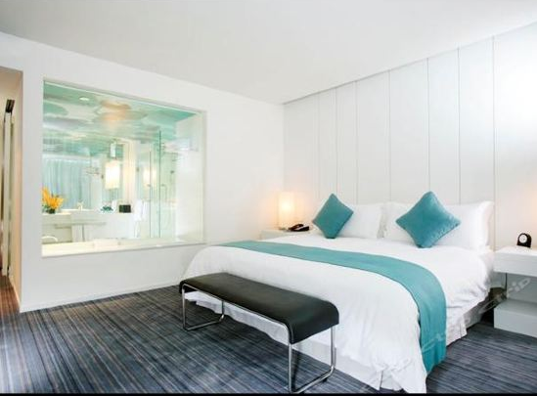 | Grand Mercure Shanghai Century Park  The hotel is an ideal spot for travelers wanting to discover the city. Traveling to the hotel is easy with Shanghai Railway Station located approximately 13km away. The closest major public transportation, Fangdian Road Metro Station, is only 900m away. Many local tourist attractions including the Century Park and Shanghai Science & Technology Museum can easily be reached with a short drive. After a long day of sightseeing, guests can retire to the comfort of the hotel. For guests' convenience, airport pickup can be arranged.  Location Distance from hotel  Shanghai Pudong International Airport 31.26 km  Shanghai Hongqiao Airport (Terminal II) 26.80 km  Address：No.1199 Ying Chun Road, Pudong, Shanghai
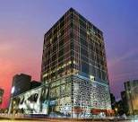 | Jumeirah Himalayas Hotel  Opened in 2011,  Shanghai jumeirah Himalayas hotel adjacent to the Shanghai new international expo center, thumb plaza, 96 square, Shanghai Oriental art center, Asia Pacific ChengHui shopping center, walk to metro line no. 7 HuaMuLu station, subway line 2 longyang road station, take it to Shanghai pudong international airport is only 7 minutes.  Location Distance from hotel  Shanghai Pudong International Airport 32 km  Shanghai Hongqiao Airport (Terminal I) 27 km  Address : No. 1108 Mei Hua Road, Pudong, Shanghai
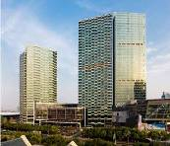 | Kerry Hotel Pudong Shanghai  Opened in 2011, Total Rooms: 574  Shanghai Pudong kerry hotel is a five-star Shangri-la group and the brand, located in Shanghai pudong kerry city, offices, hotels, service apartments and a large shopping center in an integrated fashion element of life. Is located in the heartland in the pudong new area, adjacent to metro line no. 7, the new international expo center and century park.  Location Distance from hotel  Shanghai Pudong International Airport 33 km  Shanghai Hongqiao Airport (Terminal II) 27km  Address: 1388 Huamu Road (Huamu Lu), Pudong

